**MRI instrumentation**

**Diffusion MRI**

**diffusion-weighted imaging (DWI) technology:**

The water diffusion can be detected or measured using the diffusion-weighted imaging (DWI) technology. DWI is sensitized to the water molecular motion in tissue by applying magnetic field gradients (diffusion gradients) in the RF pulse sequence. In a DWI sequence, the diffusion weighting is determined by a parameter called “b-value,” which is in the unit of second per square millimeter (s/mm2). High “b-value” generates high diffusion weighting, and no diffusion weighting is generated when b = 0. On a diffusion-weighted image, the tissue that contains high diffusing water generates hypointense signal.

**DWI application:**

The use of DWI on neurological studies has been shown that a wide range of neuropathology causes DWI signal changes. One of the most successful applications is in the stroke study. T1- and T2-wt MRI failed to detect the ischemic lesion in acute stroke. oppositely, the lesion can be detected using DWI. DWI can reveal the immediate temporal changes in ADC that occur upon induction of ischemia. The figure shows the DWI and the ADC map of a stroke model using rats. The ischemic region has elevated DWI signal intensity indicating decreased water diffusion in this region. ADC map calculated from the DWI shows decreased ADC in the same region.

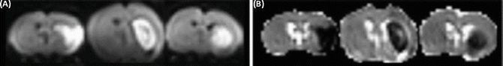

The underlying pathology of the ADC change during ischemia remains unclear. Several theories explain the observation. One of them is the cell swelling theory. This theory assumes that water diffusion is slower inside cells than in the extracellular space. The disruption of blood supply in stroke induces cell swelling (cellular edema). Water molecules then spend more time diffusing in swollen cells, and thus decreasing ADC. Another theory assumes that the changes in cell membrane permeability may contribute to the ADC reduction. A loss of active intracellular water transport with energy failure may be another cause of the decreased water diffusion..

**Diffusion Tensor Imaging (DTI):**

DTI is an extension of DWI. Diffusion is a three-dimensional process. In a uniform environment, it is isotropic in all directions and can be represented by a sphere. If water molecule movement is restricted in certain directions, the diffusion becomes anisotropic, represented by an ellipsoid. For example, in fiber-like cell structures, such as white matter tracts, the diffusion is relatively free along the long axis of the fiber tract, but restricted in the other two dimensions. The diffusion in cellular structures is described mathematically by a tensor. A tensor is a 3 × 3 matrix. The tensor of diffusion is measured using DTI with diffusion gradients in appropriate strength. After a series of mathematical manipulations, the axes of the ellipsoid diffusion and the diffusion magnitudes along the axes can be calculated.

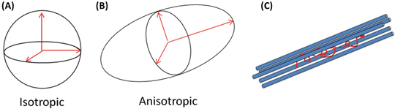

**Applications:**

Apparently the principal axis (the axis with the maximum diffusion magnitude) of the diffusion ellipsoid points to the preferred diffusion direction. It is reasonable to think that for WM, the favorite diffusion direction is along the WM tracts, and thus the principal axis is parallel to fiber tract orientation. Several methods display the principal axis, one of which is the so-called color-encoding technique. In the color-encoding technique, the three components along the directions of the principal axis are encoded with the primary colors (red, x component; green, y component; and blue, z component) and the brightness is scaled by an anisotropy index such as FA. The figure explains this method on multiple image slices of a mouse brain where the brightness was scaled by the FA value.

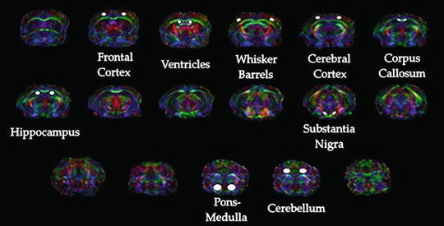

**MRI contrast and DWI:**

Conventional MRI system changed a lot since it was created through diagnose and investigation of many different kinds of tumors in any organ of the body. Before MRI we were not able to detect any tumor. The process was through very hard method to figure out the body tumors, however with time and all technologies which we already have today we could improve the image of MRI as unfortunately it was not very precise on organs like brain and liver. The difference between DWI and conventional MRI that DWI illustrates the contrasts of the region using the diffusion of water in cells as any region even it was empty it has differences in tissues and microbodies will draw the contrast of the region which will give us a map like.

**Using DWI with the conventional MRI:**

Taking a case like the stroke which arises from ischemia. In case like this using MRI without DWI will not be helpful as it will detect the problem after couple of hours and possibly more, but using DWI will detect the problem only in half an hour and maybe less than that. The point is MRI good with tumors and big tissues differences but in a case like stroke we will not figure the problem ,however DWI detects the changes in water in tissues so any stroke or different behavior will change the map which is drown by DWI.

Unfortunately we can’t replace MRI with the DWI totally as it will not be very precise on the levels of tumors it will give a precise map for the region and the hyper and hypo intense signals based on the diffusion, however it will not give anatomical information about the tumor like the MRI sequence .

Using both MRI and DWI together makes the image more complete and precise . Studies show that combining both of them helps in differentiating between benign and malignant tumors which only MRI sequence was not able to differentiate between them correctly before DWI. Another case is prostate cancer. A study by heider et al explains that using both of conventional MRI and DWI together gives a more precise and detailed imaging. Another benefit of DWI is that it does not require any hardware system, therefore it Is very easy to use it on a MRI device to get the best result. The figure shows a T2WI (conventional MRI) images and DWI images of a prostate cancer patient. Figure B is DWI and C,D are corresponding ADC maps in gray and color scale.

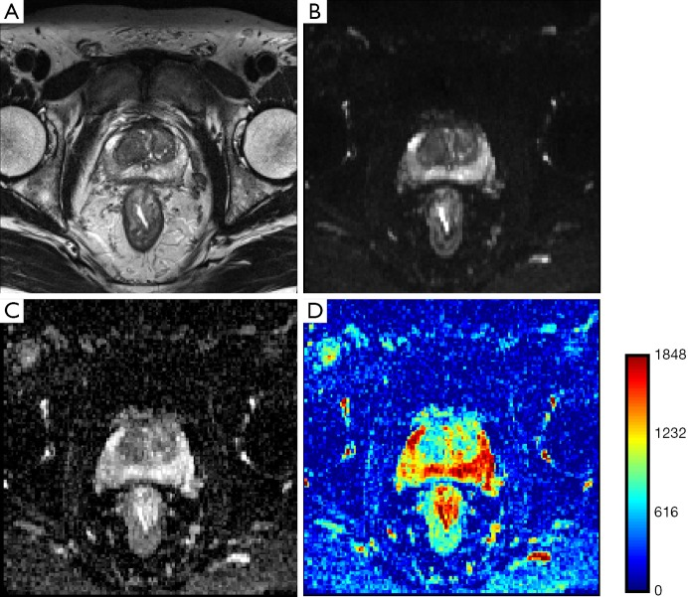

**Brain imaging:**

Diffusion tensor imaging (DTI) is one of the main branches of DWI. Its process is by taking several images from every direction of the region to develop the tensor image. Using DTI enables us to get better images when it come to fiber tracking. It also helps a lot in studying the white matter of brain depending on the diffusion which assumed to be highest parallel to the tract so it will help in studying the pathways of the brain.

**DWI Deficiencies:**

Theoretically DWI is a perfect tool for tumors and detecting any small change in the region we want to explore. Unfortunately practically the image of DWI depends on a lot of factors which may reduce its efficiency like the field homogeneity, slow gradient changes and the hardware limitations. Also low strength scanners leads to lower resolution which is one of the main reasons that DWI is not efficient alone and needs MRI sequence.